The goal of this app is quite simple, which makes it perfect to get your hands dirty learning a completely new language for developing Android apps. Another cool thing you can learn from this project is to make custom desktop widgets for Android.

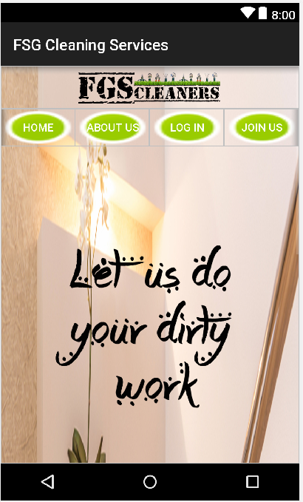

**Login and Register Service**

([Github](https://github.com/arpitkh96/AmazeFileManager))

* **Register**

If you are having the FGS Cleaning Services App for the first time in your mobile, and wish to engage in the services offered, you will be given an option to register on the App, this will give you access to the app and its provided services, as some activities are not accessible when you have not registered.

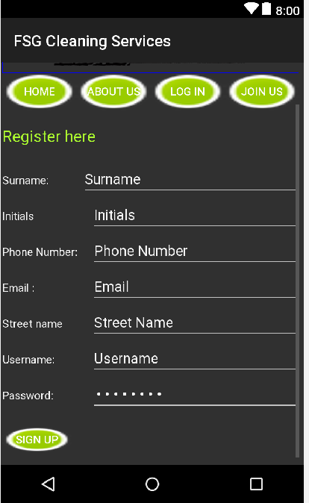

* **Login**

After you have registered, you will then use the username and password that you created when you registered on the App, to log in into the app and its services.

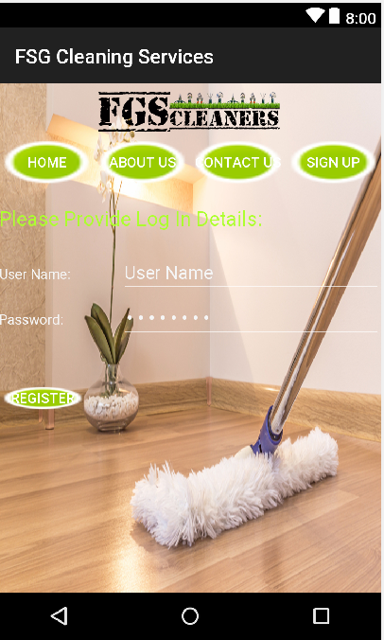

**About Us**

This is a short definition and mission statement about the FGS Cleaning Services Company as a whole.

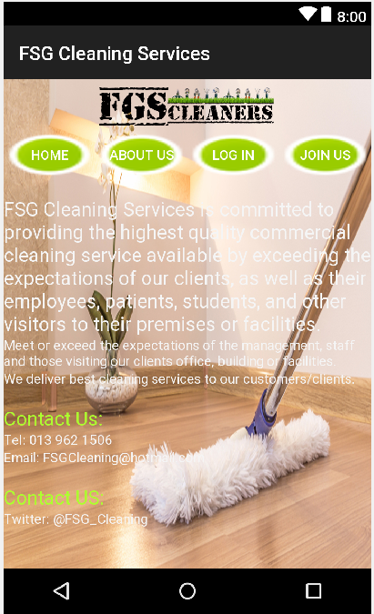

**Contact Us**

This is a short list of the company’s contact details. Including the phone number, email address and Facebook page details.

Typical Example:

26 Montgomery street

Ext 5 Eskom park 1034

Phone: 013 692 1506

Email: [FGSCleaning@hotmail.com](mailto:FGSCleaning@hotmail.com)

Facebook page: FGS Cleaners

Twitter page: @FGS_Cleaning

**Adding Customer Service**

([Github](https://github.com/arpitkh96/AmazeFileManager))

Another extremely common Android app that you can find on almost any Android device.

There are a lot of good things you can learn from this app, especially adding new customers to the database and viewing them.. But I would not recommend you to follow the coding standards used in this project as it is no way up to the mark.

This adds a customer to out database when they register with up under Sign Up.

**Booking Service Manager**

([Github](https://github.com/arpitkh96/AmazeFileManager))

This app allows you to book our cleaning services and view all of them as they are offered.

This allows you to choose the right type of service you wish have done, choose a date that is convenient for you and choose a paying plan.

**View Booking Service**

You can have access to all the bookings that you have made, have them all listed out for you to see.

Your bookings will be sorted by their date in ascending order.

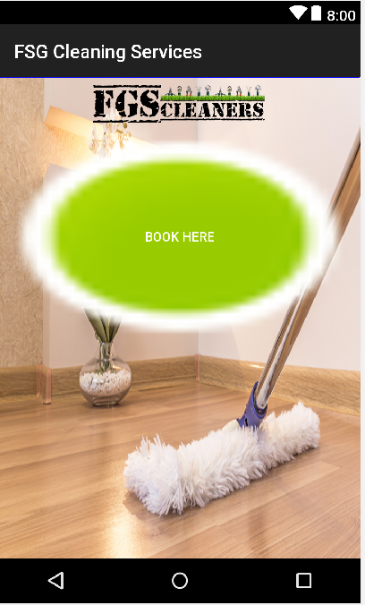

**MLManager**

([Github](https://github.com/arpitkh96/AmazeFileManager))

MLManager is a simple and straight-forward app manager for your Android device. This project is ideal for you if you want to learn how to **get detailed information about the installed apps on your device, extract APKs from those apps, and uninstall apps** and much more.

The coding standards used in this app is quite good and should be followed. It can also give you a good idea of designing clean and simple apps following the Material Design guidelines.

**Minimal To-do**

([Github](https://github.com/arpitkh96/AmazeFileManager))

If you are a beginner, this is a very simple yet cool project to start with. You will get a **good chance to learn most of the basic and fundamental aspects of Android development.**

The design of the app is decent and serves as a good starting point for beginners. But don’t follow the coding standards or package structure followed here, as they are not up to the mark and should be avoided.